**CAED LAB 08**

**Exercise**

**Write a program to check whether a given number is greater than o equal to 50, using if-else statement.**

**Check the program with the given numbers (a) 23 (b) 50**

**Code:**

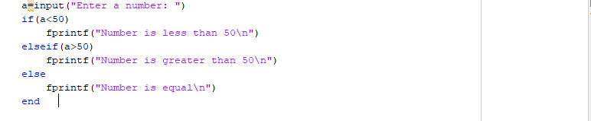

**Output:**

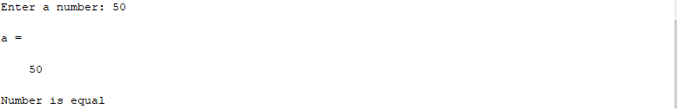

**Write a program to evaluate y = 2x + 1 if x<5, otherwise y =2x. Use the if-else statement. Check the**

**program with the value of x as (7) and (2)**

**Code:**

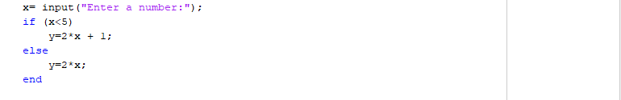

**Output:**

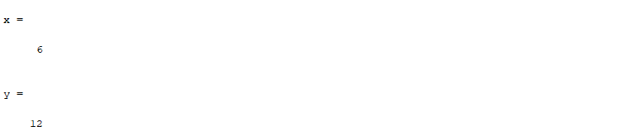

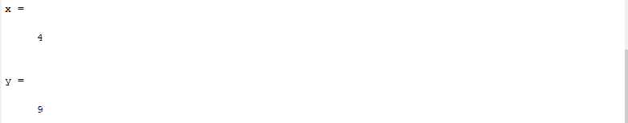

**Write a program to find the largest of the three numbers using if-else if-else statement. Check the**

**program with the given values (45,98,34) and (45,34,8)**

**Code:**

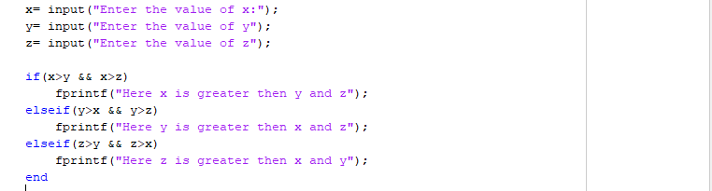

**Output:**

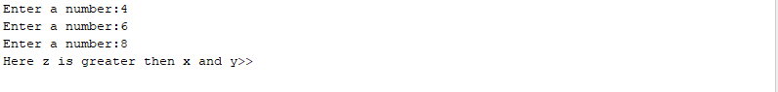

**Use a for- loop to print out the square of integers from 1 up to maxValue(take input from user).**

**Code:**

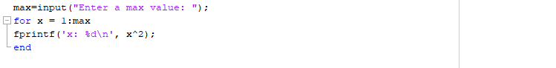

**Output:**

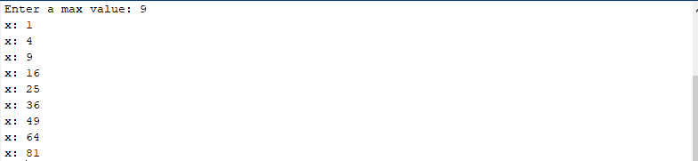

**Use a while loop to calculate factorial (10)**

**Code:**

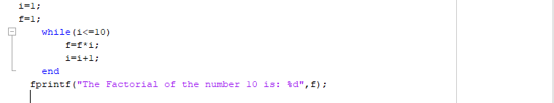

**Output:**

